Kosher Restraunt List & Map

A La Marguerite Gourmet
Price: $$
Address: 6630 Cote St Luc Road, Montreal, Quebec
Phone: ‎514-488-4111
Supervision: Vaad Hair of Montreal (MK)
Cuisine: International
Food Type: Meat

‎Atrium Coffee Shop
Address: Jewish General Hospital 5750 Côte-des-Neiges Road, Montreal, QC H3S 1Y9, Canada
Supervision: Vaad Hair of Montreal (MK)
Food Type: Dairy

‎BSTRO
Address: Royalmount Avenue, Mount Royal, QC, Canada
Supervision: Vaad Hair of Montreal (MK)

‎Café de l'Avenue
Address: 5800 Cavendish Boulevard, Côte Saint-Luc, QC H4W 2T5, Canada
Phone: ‎+1 514-485-2233
Supervision: Vaad Hair of Montreal (MK)
Cuisine: Cafe / Bakery
Food Type: Dairy

‎Café Sofia
Address: 5767 Legare Street, Montreal, QC H3T 1E4, Canada
Phone: ‎514-379-1818
Supervision: Vaad Hair of Montreal (MK)
Cuisine: Cafe / Bakery
Food Type: Dairy

‎Chez Benny
Price: $
Address: 5071 Chemin Queen Mary Snowdon, Montreal, Quebec
Phone: ‎514-735-1836
Supervision: Chief Rabbinate of Quebec (KSR) (Rabbi D. Sabbah)
Cuisine: Oriental
Food Type: Meat

‎Chez Benny Express
Address: 2075 Rue Saint Louis , Montreal, QC H4M 1P1, Canada
Phone: ‎(514) 747-2070
Supervision: Vaad Hair of Montreal (MK)
Cuisine: AmericanGrill
Food Type: Meat

‎Chez Daniel - Esposito
Address: 340 Marcel Laurin, Montreal, Canada
Phone: ‎514-747-6464
Supervision: Vaad Hair of Montreal (MK)

‎Chiyoko
Address: 2113 St-Louis, Montreal, QC
Supervision: Vaad Hair of Montreal (MK)
Cuisine: Japanese Sushi
Food Type: Meat and Parve

‎Chops Resto Bar
Address: 5322 Chemin Queen Mary,, Montréal, QC H3X 1T7, Canada
Phone: ‎+1 514-759-4677
Supervision: Vaad Hair of Montreal (MK)
Cuisine: ChineseSteak house
Food Type: Meat

‎City Grill
Address: 5055 Queen Mary Road, Montreal, QC H3W 1G4, Canada
Phone: ‎+1 514-543-5055
Supervision: Vaad Hair of Montreal (MK)
Cuisine: AmericanGrill
Food Type: Meat

‎Deli 365 (take out)
Address: 365 Bernard W., Montreal, Canada
Phone: ‎514-544-3354
Supervision: Vaad Hair of Montreal (MK)

‎Deli Boyz
Address: 5800 Cavendish Boulevard, Côte Saint-Luc, QC H4W 2T5, Canada
Phone: ‎+1 514-303-2699
Supervision: Vaad Hair of Montreal (MK)
Cuisine: Deli
Food Type: Meat

‎District Bagel
Address: 709 Lucerne Rd, Mount Royal, QC H3R 2H7, Canada
Phone: ‎+1 514-735-1174
Supervision: Vaad Hair of Montreal (MK)
Cuisine: Cafe / Bakery
Food Type: Dairy

‎Elna Bistro Restaurant
Address: 6900 Decarie Boulevard,, Montreal, H3X 2T8, Canada
Phone: ‎514-564-3462
Supervision: Vaad Hair of Montreal (MK)
Cuisine: SandwichesFish
Food Type: Dairy and Parve

‎Ernie & Ellie's Place
Price: $$
Address: 6900 Decarie Blvd. Snowdon, Montreal, Quebec
Phone: ‎514-344-4444
Supervision: Vaad Hair of Montreal (MK)
Cuisine: Chinese
Food Type: Meat

‎Exception Bistro Resto
Address: 5039 Queen Mary Road, Montreal, Canada
Phone: ‎514-344-0508
Supervision: Vaad Hair of Montreal (MK)
Food Type: Dairy

‎Federation CJA Coffee Shop
Address: 1 Carre Cummings, Montreal, Canada
Phone: ‎514-735-2208
Supervision: Vaad Hair of Montreal (MK)
Food Type: Dairy

‎Fish N Zone
Address: 5335 Queen Mary Road, Montreal, Canada
Phone: ‎514-419-4411
Supervision: Vaad Hair of Montreal (MK)

‎Gare 18
Address: 5767 Legare Street, Montreal, QC H3T 1E4, Canada
Phone: ‎514-379-1818
Supervision: Vaad Hair of Montreal (MK)

‎Iris-istible Coffee Shop
Address: 3855 Decarie Blvd., Montreal, Canada
Phone: ‎514-488-8500
Supervision: Vaad Hair of Montreal (MK)
Food Type: Dairy

‎Kebab Shop
Address: 3755 Chemin de la Côte-Sainte-Catherine, Montreal, QC H3T 1E2, Canada
Phone: ‎514-379-1818
Supervision: Vaad Hair of Montreal (MK)
Food Type: Meat

‎Kosher Pizza Bar
Address: 5800 Cavendish E6, Montreal, Canada
Phone: ‎514-488-4444
Supervision: Vaad Hair of Montreal (MK)
Food Type: Dairy

‎Kosher Pizza Bar
Address: 1225 Route 117, ST. AGATHE, Montreal, Canada
Phone: ‎514-513-2106
Supervision: Vaad Hair of Montreal (MK)
Food Type: Dairy

‎Le Plezl
Price: $
Address: 3429 Peel (corner Sherbrooke) Montreal Downtown, Montreal, Quebec
Phone: ‎514-842-4663
Supervision: Chabad
Cuisine: Italian
Food Type: Dairy and Parve

‎Luzzatto
Glatt
Address: 6445 Decarie Boulevard, Montreal, Canada
Phone: ‎+1 514-739-8535
Supervision: Rabbi Pinchus Wieder
Cuisine: Italian
Food Type: Dairy

‎Maison Ben’Jing
Address: 3755 Chemin de la Côte-Sainte-Catherine, Montreal, QC H3T 1E2, Canada
Phone: ‎514-379-1818
Supervision: Vaad Hair of Montreal (MK)

‎Mediterraneo Steakhouse
Address: 1873 St. Louis V.S.L., Montreal, Canada
Phone: ‎514-692-2647
Supervision: Vaad Hair of Montreal (MK)
Food Type: Meat

‎Metsuyan Sushi Bar
Address: 5800 Cavendish Blvd, Montreal, Canada
Phone: ‎514-744-2323
Supervision: Vaad Hair of Montreal (MK)
Cuisine: Fish
Food Type: Dairy and Parve

‎Mimimelon Restaurant
Address: 2069 Rue Saint-Louis Ville saint Laurent, Montreal, H4M 1P1, Canada
Phone: ‎15147376887
Supervision: Vaad Hair of Montreal (MK)

‎Mozart Le Grand Restaurant
Address: 5335, Queen Mary Road, Montreal, Canada
Phone: ‎514-419-4411
Supervision: Vaad Hair of Montreal (MK)
Food Type: Meat

‎Mozart Restaurant
Address: 5335a Chemin Queen Mary, Montreal, QC H3X 1T9, Canada
Phone: ‎514-419-4411
Supervision: Vaad Hair of Montreal (MK)
Food Type: Dairy and Parve

‎One Stop Kosher (take out)
Address: 6735 Darlington, Montreal, Canada
Phone: ‎514-738-3207
Supervision: Vaad Hair of Montreal (MK)

‎Pizza Bar
Address: 6680 Park Avenue, Montreal, QC H2V 4J1, Canada
Supervision: Vaad Hair of Montreal (MK)
Cuisine: PizzaPizza and more
Food Type: Dairy

‎Pizza Gourmetti
Address: 5487 Victoria Avenue, Montreal, H3W 2P9, Canada
MapDirections
Phone: ‎514-739-7707
Supervision: Vaad Hair of Montreal (MK)

‎Pizza Pita
Price: $
Address: 6415 Decarie Snowdon, Montreal, Quebec
Phone: ‎514-731-7482
Supervision: Vaad Hair of Montreal (MK)
Cuisine: Pizza
Food Type: Dairy

‎Pizza Tatty
Price: $
Address: 6540 Darlington Avenue Outremont, Montreal, Quebec
Phone: ‎514-735-8289
Supervision: Vaad Hair of Montreal (MK)
Cuisine: Pizza and more
Food Type: Dairy

‎Pret a Manger
Address: 3755 Chemin de la Côte-Sainte-Catherine, Montreal, QC H3T 1E2, Canada
Phone: ‎514-379-1818
Supervision: Vaad Hair of Montreal (MK)

‎Resto Uriel (take out)
Address: 9297 Tolhurst, Montreal, Canada
Phone: ‎514-385-9514
Supervision: Vaad Hair of Montreal (MK)

‎Saizen Sushi Bar
Address: 5177 Decarie Boulevard, Montreal, QC H3W 3C2, Canada
Phone: ‎+1 514-903-0505
Supervision: Vaad Hair of Montreal (MK)
Cuisine: Japanese Sushi

‎Shia Maki Sushi
Address: 5884-a Park Ave, Montreal, QC H2V 4H3, Canada
Phone: ‎+1 514-405-5007
Supervision: Khal Machzikei Hadas D'Chasidei Belz of Montreal
Cuisine: Japanese Sushi
Food Type: Parve

‎Shop: Beso Boutique
Address: 5497 Rue Robert-Burns, Montréal, QC H4W 2B4, Canada
MapDirections
Phone: ‎+1 514-488-5595
Supervision: Vaad Hair of Montreal (MK)

‎Shop: Best Simcha
Address: 1863 St Louis St, Saint-Laurent, QC H4M 1N5, Canada
Phone: ‎+1 514-748-5151
Supervision: Vaad Hair of Montreal (MK)

‎Shop: Cheskie Bakery
Address: 359 Bernard West, Montreal, Canada
Phone: ‎514-271-2253
Supervision: Vaad Hair of Montreal (MK)

‎Shop: Cite Cachere
Address: 4747 Van Horne, Montreal, Canada
MapDirections
Phone: ‎514-733-2838
Supervision: Vaad Hair of Montreal (MK)

‎Shop: Creative Cakes by Ilana
Address: 5500 Westbury Avenue , Montreal, Canada
Phone: ‎514-458-4279
Supervision: Vaad Hair of Montreal (MK)

‎Shop: Fooderie Mid-Town
Address: 2765 Ave Van Horne, Montreal, QC H3S 1P6, Canada
Phone: ‎+1 514-737-0393
Supervision: Vaad Hair of Montreal (MK)

‎Shop: Homemade
Address: 6915 Querbes, Montreal, Canada
MapDirections
Phone: ‎514-270-5567
Supervision: Vaad Hair of Montreal (MK)

‎Shop: Kosher Quality
Address: 5855 Victoria, Montreal, Canada
MapDirections
Phone: ‎514-731-7883
Supervision: Vaad Hair of Montreal (MK)

‎Shop: Montreal Kosher
Address: 2135 St. Louis, Montreal, Canada
MapDirections
Phone: ‎514-747-5116
Supervision: Vaad Hair of Montreal (MK)

‎Shop: Montreal Kosher
Address: 7005 Victoria, Montreal, Canada
MapDirections
Phone: ‎514-739-3651
Supervision: Vaad Hair of Montreal (MK)

‎Shop: Paradise Kosher Restaurant
Address: 11608 De Salaberry Marche de l'Ouest, Montreal, Canada
Phone: ‎(514) 421-0421
Supervision: Vaad Hair of Montreal (MK)

‎Shop: Patisserie Adar
Address: 5634 Westminster, Montreal, Canada
Phone: ‎514-484-1189
Supervision: Vaad Hair of Montreal (MK)

‎Shop: Renfells Bakery
Address: 2800 Chemin Bates, Montreal, Canada
Phone: ‎514-733-5538
Supervision: Vaad Hair of Montreal (MK)

‎Shop: The Fooderie Market
Address: 6680 Park Avenue, Montreal, QC H2V 4J1, Canada
Phone: ‎+1 514-279-3663
Supervision: Vaad Hair of Montreal (MK)

‎Shop: Westminster Gourmet
Address: 5458 Westminster, Montreal, Canada
Phone: ‎514-965-3271
Supervision: Vaad Hair of Montreal (MK)

‎Sofitel Montreal (packed food only! מזון ארוז )
Price: $$$
Address: 1155 Sherbrooke Street West, Montreal, Quebec
Phone: ‎514-285-9000
Supervision: Vaad Hair of Montreal (MK)
Cuisine: French
Food Type: Meat and Parve

‎Yakimono Sushi Bar
Address: 4210 Decarie Boulevard, Montreal, Canada
Phone: ‎(514) 484-1515
Supervision: Vaad Hair of Montreal (MK)

‎Yossi's Dizengoff Cafe/Hillel House
Price: $
Address: 3460 Stanley Street, Montreal, Quebec
Phone: ‎514-845-9171
Supervision: Vaad Hair of Montreal (MK)
Cuisine: Israeli
Food Type: Meat
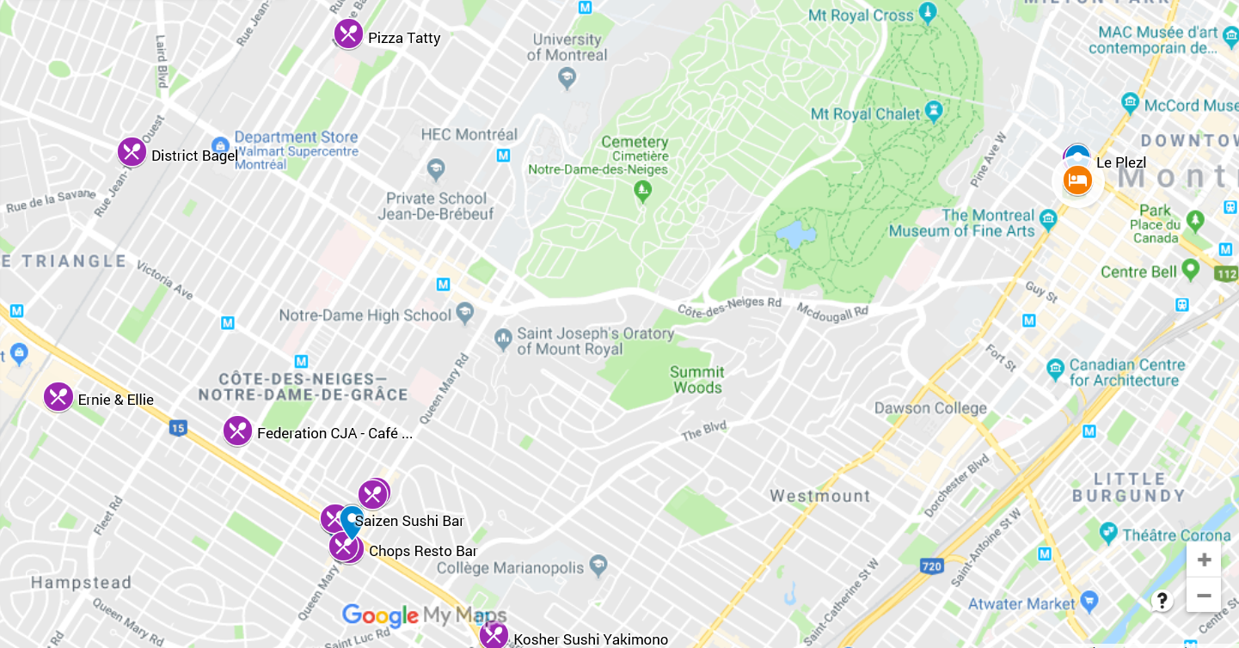
= Hotel
= Queen Mary Road & Decarie Boulevard (Bus drop off option for dinner on Oct 10th)
= Kosher Restaurants

